George Floyd
& Black Lives Matter

Accessible Summary

 | You might have heard people talking in the news about a man called George Floyd.
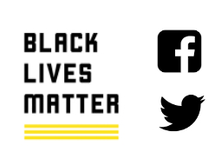 | You also might have seen people post things on social media about Black Lives Matter.
 | This is an easy read summary to help people with learning disabilities learn about George Floyd and Black Lives Matter.
 | People with learning disabilities have the right to learn about the news and join in if they want to.

George Floyd

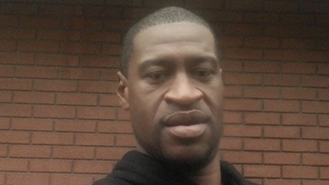 | Who was George Floyd?  George Floyd was a Black American man.  He was 46 years old.
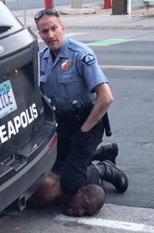 | What happened to him?  On 25th May George Floyd died while being arrested by the police.
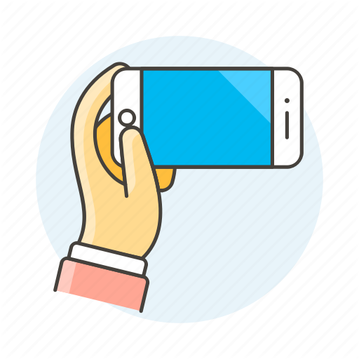 | People nearby filmed the arrest on their mobile phones.  The video shows the police putting George Floyd on the floor and leaning on his neck.  It shows George Floyd asking for help.
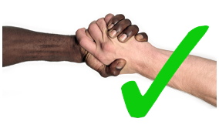 | Why is this important?  George Floyd’s death was avoidable, he should not have died that day.  Black people often get treated differently and even hurt by the police. This needs to stop.  Everyone should be treated equally and with respect.
Black Lives Matter

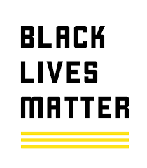 | What is Black Lives Matter?  Black Lives Matter is a group of people across the world who speak up about the unfair treatment and deaths of Black people.
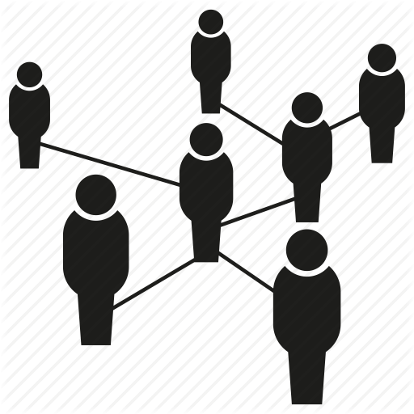 | What do they do?  They run campaigns, protests and demonstrations. People march on the streets to get their views heard about the way Black people are treated.  They are a network. They bring Black people together to discuss the problems that are affecting them.  They also run campaigns on the internet and use the hashtag #BlackLivesMatter.

Helpful Words 👍

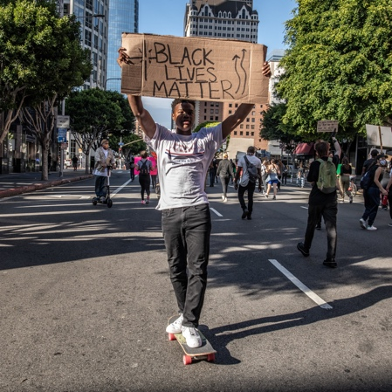
Activist

An activist is a person that speaks up for their rights and the rights of others. They might do this on the internet or in real life like marching in the streets to get their point across.

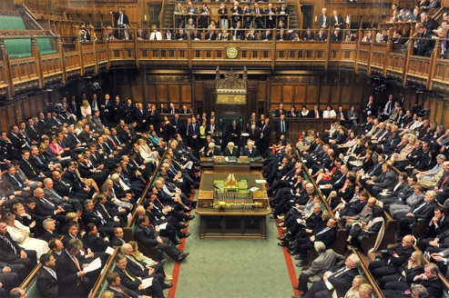
Government

A group of people who lead our country. They are voted in by people like you and me to lead the country, make rules and control where the country’s money should go.

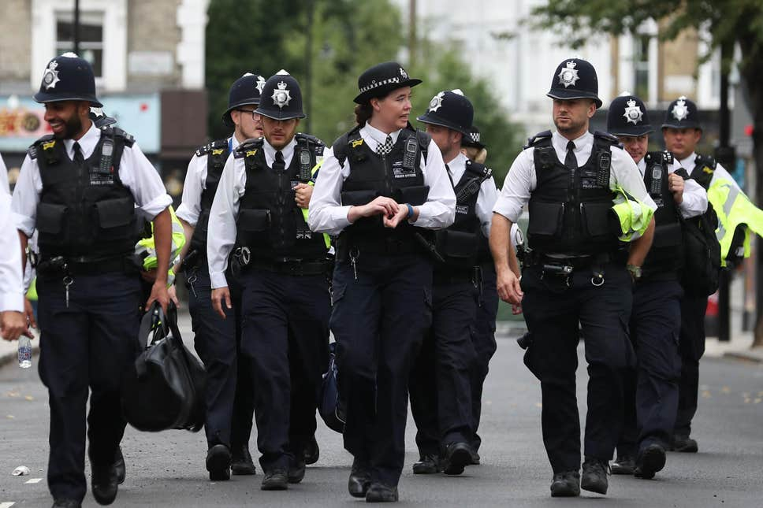
Police

The police are people who make sure that every person follows the country’s rules and laws. They are paid by the government to stop crime and to try to keep people safe.

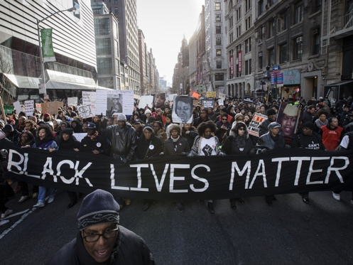
Protest

A protest is an event or action where people stand up for their rights in public.

Racism

Racism is the word we use when we talk about the unfair treatment of people who have a different skin colour to us.

For a long time, people have treated Black people badly because of the colour of their skin.
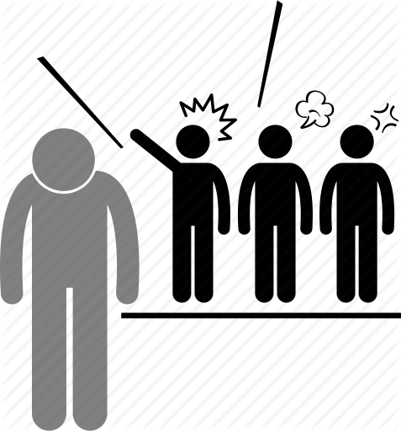

Racism can be words and actions like name calling or bullying.

But it can also be harder to spot. It can be the ways that society is run like our schools, laws and support systems.

Helpful Resources 👍

Black Lives Matter Website
https://blacklivesmatter.com/

Videos of activists telling their stories
https://blacklivesmatter.com/activist-shorts/

Liverpool Black Lives Matter Protest
https://www.youtube.com/watch?v=FTMbqZAfatY

Easy Read Equality Act
https://www.mencap.org.uk/sites/default/files/2018-02/Equality%20Act%20-%20Easy%20Read.pdf

This draft produced by Jade French 18 June 2020 and may be updated
See https://www.jade-french.com/

