The Inclusion Web
resource pack

A practical resource pack for organisations and groups to support people to increase their community inclusion and help demonstrate service effectiveness

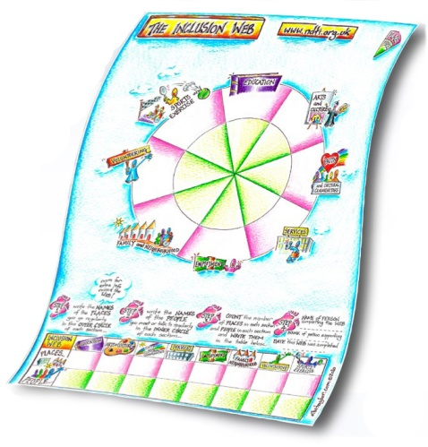
The Inclusion Web is an easy way to help people, and the organisations who support them, to look at the people and places in their life and how things may be changing over time. Developed by NDTi and refined over a number of years, the Inclusion Web has been used by many organisations to:
- Help people who need support to think about their life in the community and make plans for the future
- Evaluate change in people’s lives over time
- Measure outcomes of the support provided
The Inclusion Web has now been redesigned – illustrated in an attractive and colourful graphic style in an easy to use leaflet with step by step instructions.

We have also introduced the Inclusion Web resource pack for organisations and groups, presented in a handy folder. The pack contains a comprehensive set of resources and information to help staff, supporters and managers who work with people who need support in their lives to use the Inclusion Web effectively. It includes:
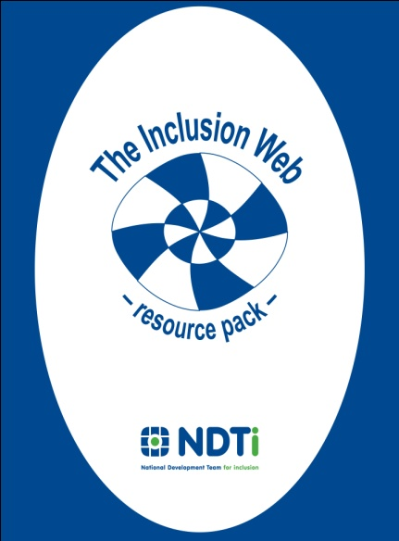
- Inclusion Web leaflets to use directly with people
- A comprehensive guide to supporting someone to use the Inclusion Web
- Guidance for managers and researchers, including articles on how and where the Inclusion Web has been used to date
- Resources to help organisations collect and analyse the results for a group of people using the Inclusion Web
- Access to more resources and support to enable organisations to use the Inclusion Web widely to really help the people they support to make positive changes in their lives.

The Inclusion Web resource pack is available from the National Development Team for Inclusion, price £25 plus £7 p&p (£7 p&p price applies to the UK mainland; we can send packs abroad but postage costs may be higher). Contact us to order a copy of the Inclusion Web resource pack and discuss how NDTi could support your organisation

Tel: 01225 789135 email: office@ndti.org.uk web: www.ndti.org.uk

Or please fill out and return the order form on the back of this leaflet

Inclusion Web resource pack

ORDER FORM

Please fill out the details below and return to the address at the bottom of this page

Name: |  |  | Job Title:
Organisation:
Address:
Tel: |  | Email: *

*required to provide updates to the pack and access to scoring forms

Number of packs required:

Please send this form with a cheque for £32 for each pack required (£25 per pack plus £7 for p&p ), made payable to NDTi to:-

NDTi
Montreux House
18a James Street West
Bath
BA1 2BT
UK

*Please note that £7 p&p price applies to the UK mainland; we can send packs abroad but postage costs may be higher so please contact us for further details.

